Online sessions
Online sessions will take place in Zoom. The link is the same for all sessions: https://viadk.zoom.us/j/4399187560?pwd=L01TOUl2UlJLRW4wbWNTTkNuaDZqZz09
Please activate your camera during the session. I tried talking into a screen for all of Spring, and it doesn’t work for me.
Keep your microphone muted until otherwise indicated.
If you have a question, use the “Raise Hand” icon .
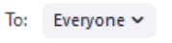
Alternatively, you can type the question in the chat. If you are uncomfortable typing the question to everyone, you can send it to just me by changing this:
You can also interact with me by using the icons in the participants list (esp. go slower): 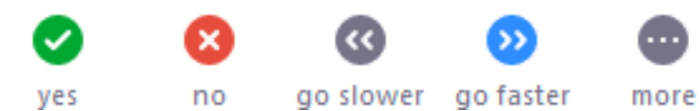
When there is time for exercises, I will move everybody (individually or in groups) into their own breakout room where you can ask for help without having to have a discussion with the whole class.

